Problem 34 a: Root locus at approx -2 ± jπ shows a gain of 10.8

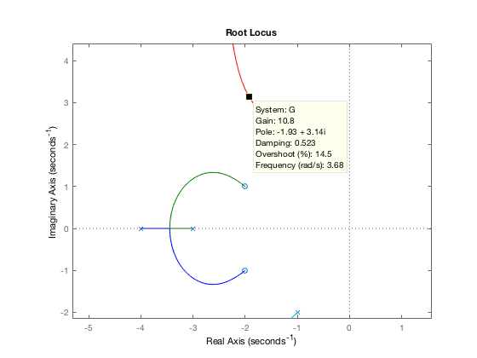

% numg = [1 4 5];

numg = 11 \* [1 4 5];

deng = conv([1 2 5], poly([-3 -4]));

G = tf(numg,deng);

T = feedback(G,1);

% rlocus(G)

% axis equal

step(T)

Problem 34 b: Step Response decreases from 1 second to 0.8 seconds

